Step 4 - Set up sensors gap
During this step, sensors gap are adjusted.

Procedure to follow for this test:
- Lock the table
- Pull up the capacitive position sensors (CPS) signals in a data viewer window
- Adjust the displacement sensor target position so that the collocated DISP channels read out fewer than 400 counts on Dataviewer (a bit less than .0005”).
- Lock the target
- Write down the mean values and standard deviation in the table below in two configurations. For the first measurement both ADE boxes are powered. For the second measurement, one of the ADE boxes is off to reduce the cross talk. Signal statistics can be obtained in the data viewer plot window (go to /edit/DataSets/).
Procedure to be revised. For the next units, we might consider using shims to set up the gaps. Then redo the zero offset using the knobs. Discussions are going on. Decision pending.
Notes:
- Before starting the gap set up, the targets are typically far from their target and consequently out of range. The signal should be +32000 counts. However, when the ADC saturates it can go to 0. The bottom line is that a 0 count signal doesn’t mean that the sensor is broken.
- When the target to sensor gaps gets larger, the MEDM count value increases (maximum gap is positive). When the target to sensor gaps gets smaller, the MEDM count value decreases (minimum gap is negative).

Table locked | Both ADE boxes on |  | One ADE boxe ON at the same time
Sensors | Offset (Mean) | Std deviation | Offset (Mean) | Std deviation
V1 | -69 | 1.1
H1 | -52 | 0.8
V2 | 257 | 1.6
H2 | 334 | 0.7
V3 | 170 | 1.8
H3 | -235 | 1.0
Table - Set-up sensors gap

Note: Here are the values with the table locked and the access Walls installed

Issues/difficulties encountered during this test: there is a big cross talk between the two ADE satellite boxes. (The first satellite box drives H1, V1, H2, V2. The second one drives H3, V3). This is why the standard deviation is bigger on the first measurement, when both satellite boxes are ON.

Acceptance criteria:
- All mean values must be lower than 400 cts (a bit less than .0005”).
- All standard deviations below 5 with one box off.

Test result: Passed: X Failed: .

Step 5 - Measure the Sensor gap
The test verifies that sensors gap measured on the Jig doesn’t change after the assembly.

Procedure to follow for this test:
Measure the gap between the probe and the target using Teflon shims on the Jig and once sensors have been installed on the table. Next, fill the table below.

Sensors | Gap measured on the Jig | Gap measured on the Table | % of change
V1 |  | 0.080
H1 |  | 0.080
V2 |  | 0.080
H2 |  | 0.080
V3 |  | 0.080
H3 |  | 0.080
Table 1 - Sensors gap

Note: Jig measured gaps for unit #1 have not been measured. Gaps measured on the table are close from 0.080” for every sensor. No data for Jig-measured gaps for Unit#1.

Issues/difficulties encountered during this test: At least one target has been scratched (see picture). However, this should not affect the system performance. To be demonstrated.

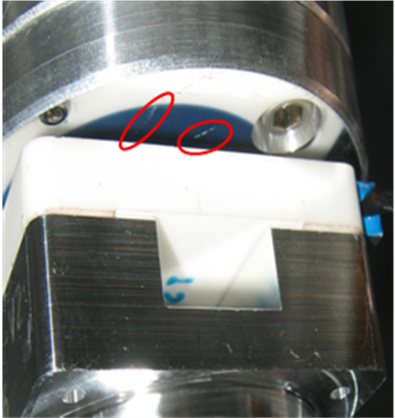
Figure - Scratch on target

Acceptance criteria:

- Change of gaps lower than 2% (reference is the gap measured on the Jig)

Test result: Passed: ? Failed: .

Step 6 - Check Sensor gaps after the platform release
During this test, the motion of the table between the locked and the unlocked position without dial indicators is evaluated.

Procedure to follow for this test:
- Remove dial indicators
- Pull up the CPS signals in a data viewer window
- Lock the table
- Write down CPS mean values in the table below
- Unlocked the table
- Write down CPS mean values in the table below

Tricks: Signals statistics can be obtained in the data viewer plot window (Go to /Edit/Data sets/ ).

 | Locked | Unlocked | Diff  unlocked - locked
Sensors | Offset (Mean) | Offset (Mean) | Diff  unlocked - locked
V1 | -69 | -62 | -7
V2 | -52 | -223 | -171
V3 | 257 | -540 | 797
H1 | 334 | -93 | 427
H2 | 170 | -782 | 952
H3 | -235 | -830 | 595
Table– Sensor gaps after platform release

Issues/difficulties/comments regarding this test: Nothing to report

Acceptance criteria:

- Absolute values of the difference between the unlocked and the locked table must be below:
  - 1200 cts for horizontal sensors (~0.0015”)
  - 1600 cts for vertical sensors (~0.002”)
- Considering the acceptance criteria of step 4, all mean values must be lower than
  - 1600 cts for horizontal sensors (~0.002”)
  - 2000 cts for vertical sensors (~0.0025”)

Test result: Passed: Failed: .

Step 7 - Check range of motion (hand pushing)
The two following tests enable to verify three points:
- Sensors signs
- Sensors range of measurement
- To double check the optical table range of motion

Step 7.1 – Test Nº1
This test requires two persons in the clean room and one person in front of the computer. Dial indicators must be installed as described in appendix 3. However, they were not installed during testing of HAM – ISI - LHO – Unit #1. Corresponding estimated displacements are based on a nominal value of 826count/mil (measured at step 12).
Vertical displacement sensors:
At each corner, push down gently (uniformly) on the optic table and watch the response in dataviewer. While pushing up/down, you have to make sure that the table is not rotating. All sensors should respond with the same sign. When the table is going down (-Z), voltage of vertical sensor is going in negative direction. Push up/down until the optic table is in contact with the locker. Report the MEDM count values in the table below.
Horizontal displacement sensors:
At each corner, push the structure tangentially at the plane of the sensors in one direction. While rotating, you have to make sure that the table is not going up/down. All sensors should respond with the same sign. When the table is turning clockwise (viewed from top) or -RZ, voltage of horizontal sensor is going in positive direction. Rotate until the optic table touches the locker. Report the MEDM count values in the table below.
Note: Motions (mil) presented in the table are obtained after calibration
 | CPS read out (Counts) |  | Calculated after calibration |  | Dial indicators (up/down)
Sensors | UP | Down | UP (mil) | Down (mil) | A | B
V1 | 20631 | -19327 |  |  | 24 / -23 | 24 / -24
V2 | 18714 | -18139 |  |  | C | D
V3 | 19631 | -20730 |  |  | 25 / -23.5 | 24.5 / -21.5
 | CPS read out (Counts) |  | Calculated after calibration |  | Dial indicators
Sensors | CW(-RZ) | CCW | CW (mil) | CCW (mil) | A | B
H1
H2 |  |  |  |  | C | D
H3
Table - Optic table range of motion

Issues/difficulties/comments regarding this test: the results indicate that all displacement sensor signals have the same sign all the way through the read chain.

Step 7.2 – Test Nº2
The main thing here is we want to make sure our Actuators & Sensors have zero chance of ever contacting (the lockers should always limit the Actuators/Sensors from closing their gaps).

Procedure to follow for this test:
- Apply manually a force collinear to the sensor axis you are testing (+ & - directions)
- For the CPS’s
  - Move the table such that the target is as close as you can get it to the Sensor Head. This motion is monitored visually and the Sensor counts are recorded.
  - Move the table such that the target is as far as you can get it to the Sensor Head. This motion is monitored visually and the Sensor counts are recorded.
- For the Actuators, viewing all possible contacts point was a little tough. Here we had one person watching the Actuator while two people moved the table in every direction possible. If no gap contacts were made, we gave the Actuator a positive “X”/PASS.

Displacement sensors and actuator gap check:

Sensors and actuator location | Negative Read out (counts) | Positive Read out (counts) | Gap check
V1 |  |  | X
V2 |  |  | X
V3 |  |  | X
H1 |  |  | X
H2 |  |  | X
H3 |  |  | X
Table - Sensor and Actuator gap check

Acceptance criteria:

- Step 7.1
  - Absolutes value of all estimated motions must be higher than 16000 counts (~.020").
- Step 7.2
  - No contact point on sensors
  - Absolute value of sensor read out must be higher than 20000counts (~0.024”)
  - No contact point on actuators

Test result: Passed: Failed: .

Step 8 - Capacitive position sensor Power Spectrum
The following test verifies the functioning of Capacitive Position Sensors as well as the existence of crosstalk between sensors satellite boxes. This measurement is performed with the table locked.

Power spectrum measurements are performed via DTT with the following parameters:
- Fourier tools
- BW = 0.02Hz
- Start = 0.05Hz
- End = 100Hz
- Average = 25

The testing configurations are the followings:
- Satellite boxes 1 and 2 powered ON (For the next units, the two satellite boxes should be synchronized)
- Satellite box 1 powered ON and satellite box 2 powered OFF
- Satellite box 1 powered OFF and satellite box 2 powered ON

The table must be locked for this test

Tricks: Don’t forget to save each power spectrums as a reference

Issues/difficulties/comments regarding this test: Capacitive sensors use electric field for sensing. When multiple, independent capacitive sensors are used simultaneously, the electric field from one probe may be trying to add charge to the target, while another sensor is trying to remove charge. This conflicting interaction with the target will create errors in the sensors’ outputs (see figure). This problem is easily solved by synchronizing the sensors. Synchronization sets the drive signal of all sensors to the same phase so that all probes are adding or removing charge simultaneously and the interference is eliminated. Interferences between ADE boxes can be roughly estimated by measuring standard deviation when one out of two satellite boxes is off.

Results: Figure 3 presents power spectrums of capacitive position sensors when satellites boxes are ON (subplot 1) and one out of two satellite boxes is OFF (subplot 2 and 3). In subplot 1, crosstalk between satellite boxes creates a series of peaks (fondamental at 0.35Hz).

SVN File: DTT results location is posted at :
/opt/svncommon/seisvn/seismic/HAM-ISI/X1/Data/unit_1/dtt

CPS calibration:
The CPS power spectrums are calibrated by using the measured sensibility at step 12 (30.2nm/cts).
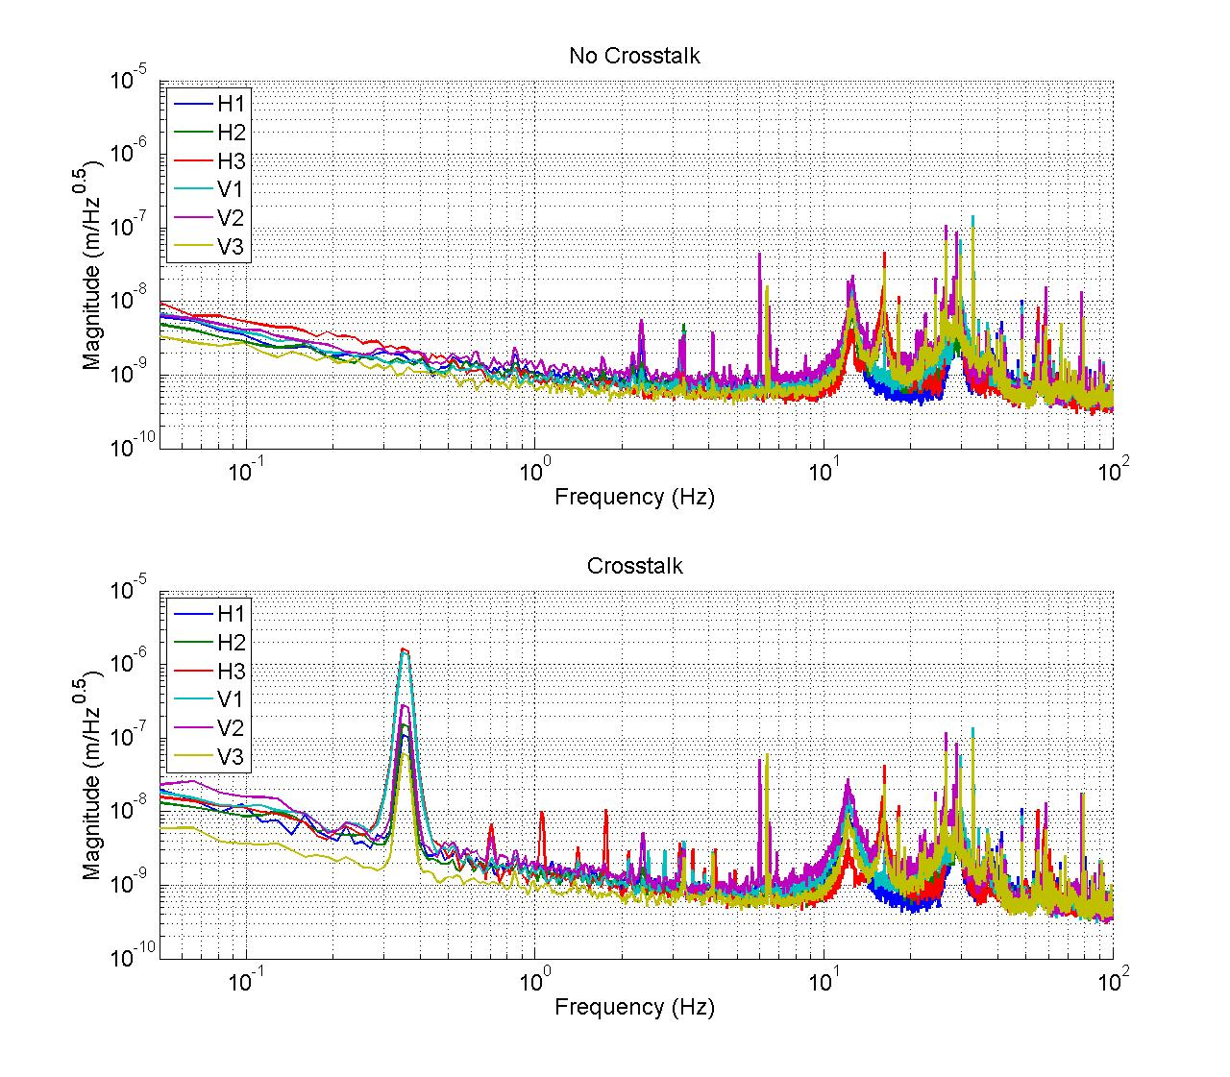
Figure - Calibrated CPS power spectrum

Acceptance criteria:
- No cross talk (peaks at low frequencies + harmonics on measurements)
- Magnitude of power spectrums must be
  - Less than 5e-10m/√Hz at 0.1Hz
  - Less than 5e-10m/√Hz at 1Hz
  - Less than 5e-10m/√Hz at 10Hz

Test result: Passed: Failed: .

Step 9 - GS13 power spectrum

Documentation: DISPs: LLO May 23 2008 DISPs and GEOs LLO Aug 14 2008 DISPs LHO May 30 2008 DISPs and GEOs LHO June 10 2008

During this test, functioning of GS13 geophones is verified once they have been installed in the HAM-ISI. To perform this test, power spectrums are measured in different configurations (table locked and unlocked with different tilt angle).While testing HAM-ISI LHO Unit #1, we noted that one GS13 geophone didn’t work when the table was tilted.

This measurement is performed via DTT with the following parameters:
- Fourier tools
- BW = 0.02Hz
- Start = 0.05Hz
- End = 250Hz
- Average = 25

The testing configurations are the followings:
- Table locked
- Table unlocked (free)
- Table unlocked tilted (+/-Rx – Mass above B and C lockers – Shims below A and D lockers and vice versa)
- Table unlocked tilted (+/-Ry – Mass above C and D lockers – Shims below A and B lockers and vice versa)

While testing HAM-ISI LHO Unit #1, we noted the following problem:

Table locked
We measured geophones power spectrum when the table was locked. Geophones respond properly.

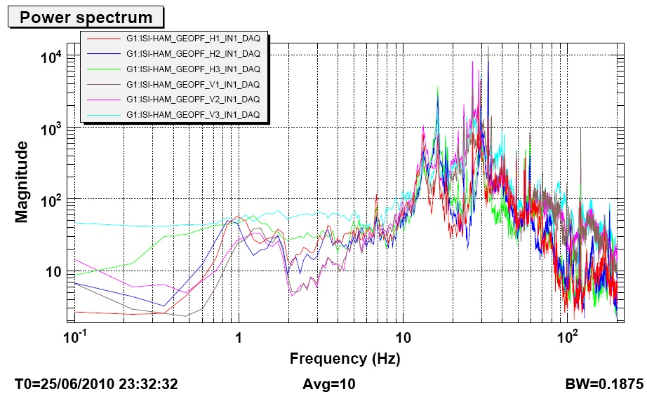
Figure - Geophones power spectrum when the optic table is locked

SVN File : 20100625_locked_table.xml

Table unlocked
We measured geophones power spectrum when the table was unlocked. This time, Geophone H3 has a different power spectrum from H1and H2. If the table was rubbing all geophone would be affected.
Before pulling out the GS-13, the ISI table was visually checked for mechanical shorts (none were found). As another system/pod check, the ISI table was tilted in a couple of different states (by placing weight on table) such that the pod would be angled "down" & angled "up".

The pod was removed and hung up by two cranes. With the TOP tilted down, we did not notice any change in the H3 performance (we were looking at DataViewer, the signal looked noisy, and would only show big seismic bumps and then quickly damp that out, and return to the noisy state).
With the BOTTOM tilted down, H3's performance totally changed---for the better. H3's signal looked like its fellow H1 & H2. A Power Spectrum confirmed that H3 looked like the other GS13s when the BOTTOM was tilted down.

The attachment's top plot shows the GS13s with the ISI weight down on the Northern end of the table. The bottom plot shows a balanced & unlocked ISI (faulty H3 geophone).

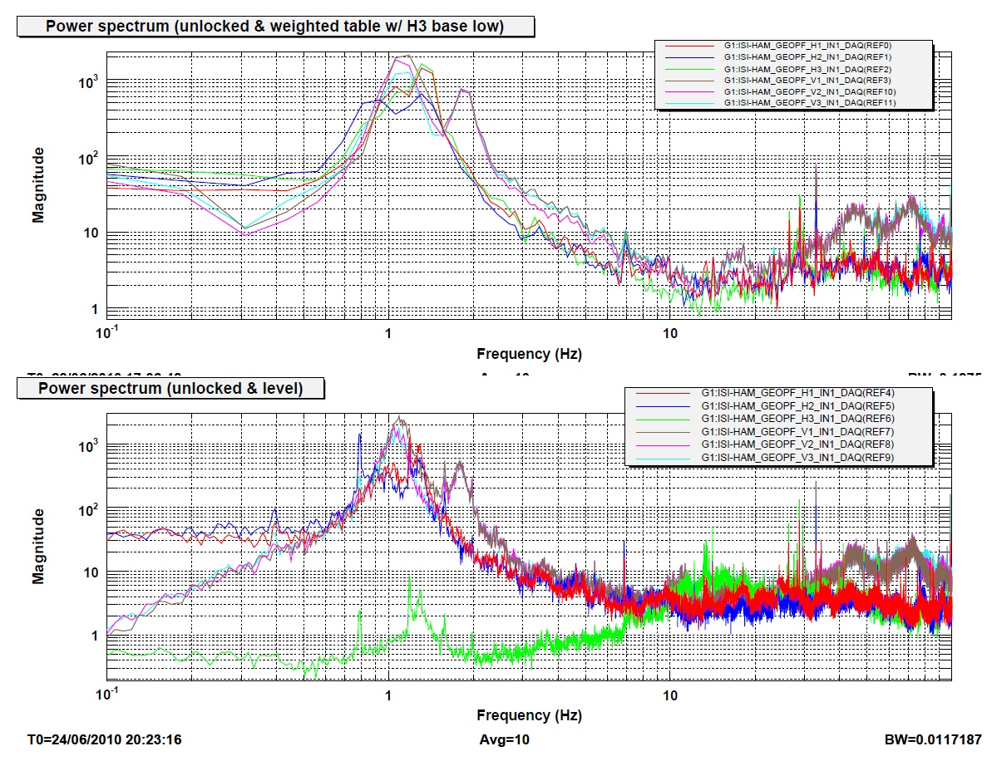
Figure - Geophones power spectrum after and before change of H3 Geophones

After changing the faulty geophone, we consider all geophones are working properly.

Power spectrums after swapping H3/ GS13 - SVN File: 20100628_H3gs13_problem.xml

Calibrated GS13
The GS13 are calibrated with information reported in the appendix 8. Geophones signals include Geophones mechanical, GS13 interface chassis and anti aliasing filter responses. The sensors responses are compensated to evaluate the real motion of the optic table. Anti-aliasing and down-sampling filters are not considered for this compensation.

GS13 Seismometer: 3 zeros @ DC and 2 poles (Q=4.5)@ 1 Hz

GS13 Interface board: 1 zero @ 10 Hz - 1 pole @ 50 Hz, 1 pole @ 2KHz and 1 pole @ 2.4KHz

GS13 total gain: 3.0034e+008 cts/m @DC

The following figure presents the calibrated geophones responses.

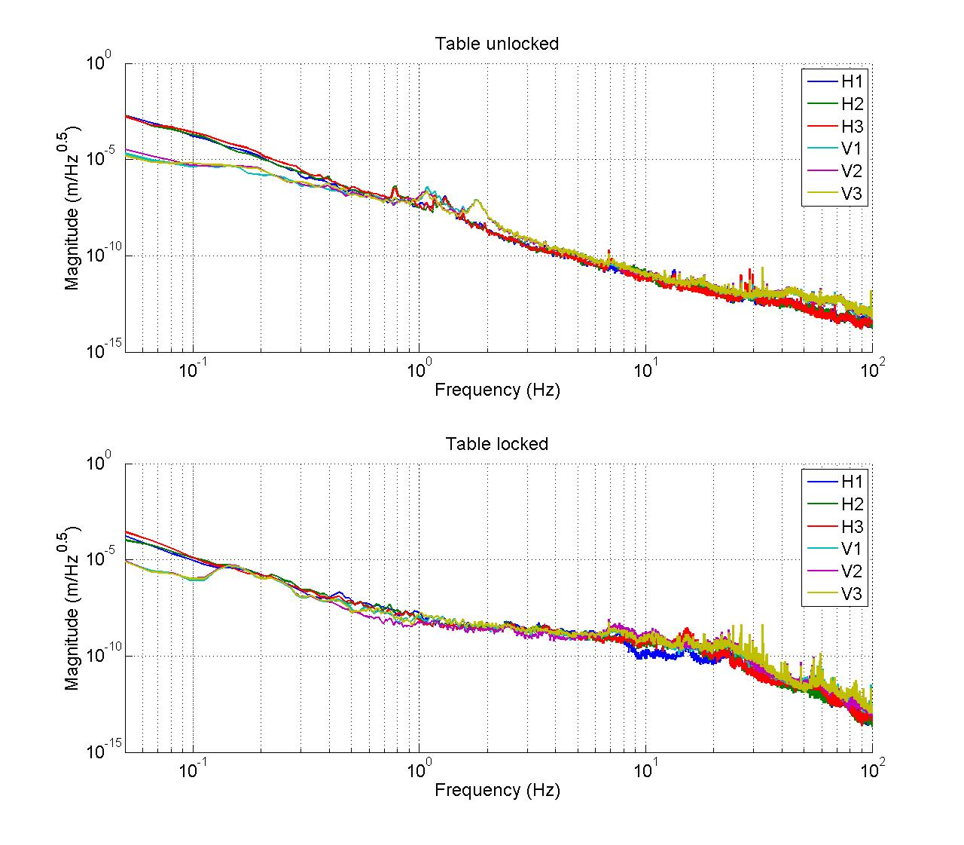
Figure – Power spectrum Calibrated GS13

SVN File: 20100713_lock_unlock_geo_spectra.xml

Acceptance criteria:
- Table locked
  - Less than xx at 0.1Hz
  - Less than xx at 1Hz
  - Less than xx at 10Hz
- Table unlocked (no tilt)
  - Less than xx at 0.1Hz
  - Less than xx at 1Hz
  - Less than xx at 10Hz
- Table unlocked (tilt Rx & Ry)
  - Less than xx at 0.1Hz
  - Less than xx at 1Hz
  - Less than xx at 10Hz
Test result: Passed: Failed: .

Step 10 - Coil Driver, cabling and resistance check
Before driving actuators, a few tests have to be carried out to check for shorts and actuator damage.

MEDM
- In MEDM open G1ISIHAM_HAM_OVERVIEW.adl at the following location : /opt/rtcds/geo/g1/medm/g1isiham/G1ISIHAM_HAM_OVERVIEW.adl
- Edit the watchdog values with the following parameters

Watchdog | Limit (counts) | Safe Limit (counts)
STS | 20000 | 30000
GS13 | 20000 | 30000
CPS | 20000 | 30000
Actuators | 20000 | 30000
Table - Watchdog set-up

On the actuator cable (vacuum side of the feedthrough)
The actuator cable is a three pin cables. All three pins are connected to a voltage drive, even though only two pins are used to drive actuators.
Pins are connected such as:
- Pin #1 (left pin in view below) is neutral return
- Pin #2 (middle pin) is the drive pin
- Pin #3 (right pin) is shield ground.

Make sure the shield ground is not connected to the middle pin of the plug. If not, swap middle pin with pin #3.

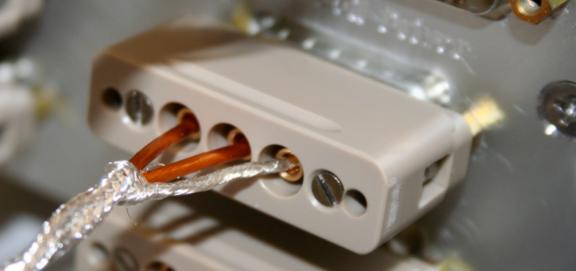
Figure – Actuator cable plugged on the feedthrough

Procedure to follow for this test:
- On the coil Driver (D0902744)
- Turn D0902744 OFF
- Disconnect the actuator cable at the back side of the coil driver
- Measure the resistance between the side pins and the middle pin of the actuator cable
- Proceed to the next one.
- Report the measured resistances
- Reconnect actuator cable to the coil driver
- Turn D0902744 ON
- Make sure all LEDs on the front panel are green

With coil driver S1000266 and S1000267

Actuator | V1 |  | H1 |  | V2
Coil driver | S1000266 – Coarse 1 OUT |  | S1000266 – Fine 1 OUT |  | S1000266 – Fine 2 OUT
Cable # | 25 |  | 26 |  | 27
Resistance  (Ohm) | P1 - P2 | P2 - P3 | P1 - P2 | P2 - P3 | P1 - P2 | P2 - P3
Resistance  (Ohm) | 6.5 | O.L (infinity) | 6.5 | O.L (infinity) | 6.5 | O.L (infinity)

Actuator | H2 |  | V3 |  | H3
Coil driver | S1000266 – Coarse 2 OUT |  | S1000267 – Coarse 1 OUT |  | S1000267– Fine 1 OUT
Cable # | 28 |  | 29 |  | 30
Resistance  (Ohm) | P1 - P2 | P2 - P3 | P1 - P2 | P2 - P3 | P1 - P2 | P2 - P3
Resistance  (Ohm) | 6.5 | O.L (infinity) | 6.5 | O.L (infinity) | 6.5 | O.L (infinity)
Resistance  (Ohm) | -0.307 V |  | -0.298 V |  | -0.301 V
Table - Actuators resistance check

After swapping S1000267 by S1000269 (blown fuse), we re-measured the coil driver output.

Actuator | V3 |  | H3
Coil driver | S1000269 – Coarse 1 OUT |  | S1000269 – Fine 1 OUT
Cable # | 29 |  | 30
Resistance  (Ohm) | P1 - P2 | P2 - P3 | P1 - P2 | P2 - P3
Resistance  (Ohm) | 6.5 | O.L (infinity) | 6.5 | O.L (infinity)
Table - Actuators resistance check

Average output voltage old configuration (S1000266 and S1000267) for 1000 counts |  |  |  |  | -0.3033 |  | V
Standard deviation output voltage old configuration for 1000 counts : |  |  |  |  | -0.0034 |  | V
Average output voltage new configuration (S1000266 and S1000269) for 1000 counts |  |  |  |  | -0.3037 |  | V
Standard deviation output voltage new configuration for 1000 counts |  |  |  | -0.0029 |  | V

Note: Measuring the voltage enable to check pins signs but is not sufficient to ensure a proper functioning of the coil driver (current output also have to be checked; see III.j). All fuses LEDs must be green.

Issues/difficulties/comments regarding this test: First time we tried to put an offset on one actuator; we blew up the coil driver fuses as indicated by the LEDs on the front panel. So we double-checked the resistance of the actuators to see if there was a short. No short was found, however actuators were not connected to the correct pins: the coil driver has a three pins output. Actuators should be connected to the middle pin and one of the side pins. It was initially connected to the two side pins. The middle pin of the coil driver was grounded.

Acceptance criteria:

- The measured resistance between the middle pin and one side pin must be 6.5 ohms
- Actuator neutral pins must be connected on pin #1 (left side pin of the plug)
- Actuator drive pins must be connected on pin #2 (middle pin of the plug)
- Actuator ground shield pins must be connected on pin #3 (middle pin of the plug)
- All LEDs on the coil driver front panel must be green

Test result: Passed: X Failed: .

Step 11 - Actuator Sign and range of motion (Local drive)
In this step, actuators signs are verified and the range of motion is measured when the table is moved by actuators.

Step 11.1 - Actuator sign

Procedure to follow for this test:
- Connect actuators to coil driver
- Open MEDM and data viewer (Visualize actuators and sensors signals)
- In MEDM, drive an offset of 300 counts on one actuator in the damping filter bank
- In dataviewer, make sure that a positive offset drive gives a positive sensor offset
  - If not, turn D0902744 OFF, swap pin #1 (not the shield) with the middle pin on the accuglass cable
  - Turn D0902744 ON
  - Retest
- Repeat for every actuators

PASSED!! 8/10/2010

Step 11.2 - Range of motion - Local drive
In this step, the range of motion of the optic table is checked when applying a local drive on actuators.

Procedure to follow for this test:
- Set actuators watchdog to 30001counts
- GEOPHONE to 40, 000 counts
- In the Damping filters bank
  - Set the gain to 0 in every directions
  - Set the ramp time to 20s in every directions
  - Set a 10000 counts offset
  - Change the gain to 3 (drive one actuator at the time)
- Write position sensors read out
- Drive a negative offset on all vertical actuators
- Write down position sensors read out

 | Positive and negative offset Drive(+/-30000 counts)
 | V1 | V2 | V3 | H1 | H2 | H3
V1 readout (counts) | 20088  -19439 | -1989  -353 | -8540  8685 | X | X | X
V2 readout (counts) | -6256  4818 | 26420  -24717 | -8118  7165 | X | X | X
V3 readout (counts) | 6022  -6601 | -15782  152001 | 21595  -22703 | X | X | X
H1 readout (counts) | X | X | X | 23863  -24419 | 15560  -17650 | 16362  -17558
H2 readout (counts) | X | X | X | 17716  -16627 | 23311  -24489 | 17221  -16864
H3 readout (counts) | X | X | X | 13668  -13163 | 13626  -13296 | 25018  -25206
Table - Range of motion - Local drive

*note vertical dial indicators were contacting for this measurement
note: we had glitches over 30k on the gs13s for these moves

Acceptance criteria:

- Main couplings read out must be at least 20000 counts (24”)
- Signs of actuators drive and sensors read out have to be the same

Test result: Passed: X Failed: .

Step 12 - Vertical Sensor Calibration
During this test, the vertical sensitivity of the position sensors is measured.

Procedure to follow for this test:
- Install Dial indicators as described in appendix 9 and set to zero when the table is unlocked
- Set actuators watchdog to 30000counts
- At this point, change of basis matrices haven’t been populated in the MEDM window.
In G1ISIHAM_HAM_CONTT2ACT_LABELLED, place one in the boxes at lines V1, V2 and V3 of column Z.
- In the Isolation filters bank
  - Set the gain to 0 on Z direction
  - Set the ramp time to 20s
  - Set a 10000 counts offset on Z direction
  - Change the gain to 2
- When driving, make sure there is no contact between the table and the lockers. If the table is touching, reduce offset.
- Write down dial indicators and position sensors mean values
- Drive a negative offset on all vertical actuators (make sure there is no contact between the table and the lockers)
- Write down dial indicators and position sensors mean value
- Compute sensitivity using ADC calibration:
2¹⁵ Count/20V = 32768 Count/20 V = 1638 Count/Volt
- Reset the actuators watchdog at 20000counts

Note: Horizontal sensor calibration is not been performed.

Corner | Dial indicator  readout for the negative drive | Dial indicator  readout for the 0 drive | Dial indicator  readout for the positive drive | Difference
A | -18 | 0 | 21 | 39
B | -18.5 | 0 | 20 | 38.5
C | -18 | 0 | 19.5 | 37.5
D | -18 | 0 | 19.5 | 37.5
Average | -18.125 | 0 | 20 | 38.125

Sensors | Counts | Counts | Counts | Difference (Counts)
V1 | -15697 | 16 | 15807 | 31504
V2 | -15577 | -6 | 15782 | 31359
V3 | -16502 | -328 | 15895 | 32397
 |  |  | Average | 31753
Table - Calibration of capacitive position sensors

Vertical sensitivity: 31753/38.1= 833 count/mil
or 833 count/mil * 1/1638 V/count = 0.509V/mil
or 25400 nm/mil * 1/833 mil/count = 30.5 nm/count

Nominal Calibration

CPS Sensitivity: 20V/0.039" = 20V/39mils = 0.513V/mil

Calibration in counts: 2¹⁵ / 20 * 20/39 = 840 count/mil
or 25400 nm/mil * 1/840 mil/count = 30.2nm/count

Change = (833-840)/840= -0.8%

Issues/difficulties/comments regarding this test: nothing relevant to report.

Acceptance criteria:

- Deviation from nominal value < 2%. Nominal value is 840 count/mil.

Test result: Passed: Failed: .

Step 13 - Vertical Spring Constant

Documentation: LLO Mar 5th 2008 LHO May 7 2008
Passes if: Spring constant is within +10%/-1% of 2.41e4 N/m (HPD FEA Results).

This test verifies the vertical spring constant. The procedure is detailed below:
- Remove dial indicators
- Write down initial position of the table given by position sensors
- Place calibrated weights at various positions on Stage. The masses are placed at equal radii from the center of Stage 1, at symmetric angles around the table. If possible, use the hatches as reference points.
- Measure displacements with position sensors
- Use at least 2 loads for this measurement. Make sure the optic table is not touching the lockers
- Repeat the measurement twice
- Fill the table below

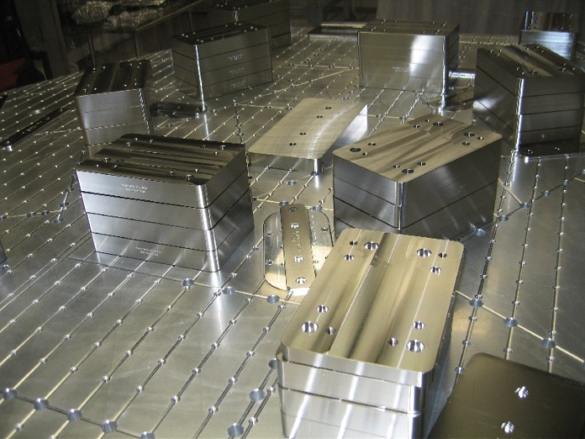
Figure – Vertical spring constant measurement – Hatches as reference points

Results presented below are obtained after the initial sensors calibration (before changing the feedthrough that created a 25% error on calibration - 632couts/mil instead of 840 mil/count). The force indicated in this table is the force applied on one hatch.

F (N) | 3 stacks of 1 type 02’s
 | Diff sensors (count) | mil | m | K (N/m)
V1 | -4797
V2 | -4457
V3 | -4333

F (N) | 29.85 =3 stacks of 3 type 02’s ??
 | Diff sensors (count) | mil | m | K (N/m)
V1 | -12739
V2 | -12700
V3 | -11352

Table - Vertical spring constant

The nominal vertical spring constant is 2.428e5N/m

V1 Stiffness | 8.21E+04 | N/m
V2 Stiffness | 8.11E+04 | N/m
V3 Stiffness | 8.10E+04 | N/m
Vertical spring constant |  | 2.442E+05 | N/m
 |  | 0.58 | % error with specified value

Issues/difficulties/comments regarding this test: nothing relevant to report.

Acceptance criteria:

- Spring constant is within +/- 1% of 2.41e4 N/m (HPD FEA Results).

Test result: Passed: X Failed: .

Step 14 - Static Testing (Tests in the local basis)
This test verifies three points:
- Actuators-sensors readout chains
- Static main coupling and cross coupling
- Actuator power (driving signal and actuator response)

Procedure to follow for this test:
- Open MEDM
- Open dataviewer and visualize actuators and sensors signals
- Write down initial position of the table given by position sensors.
- Drive an offset of 300 counts on one actuator (one at the time) in the damping filter bank
- Write down the new position of the table given by position sensors
- Compute displacements and report in the table below

Vertical actuators
A positive offset on one vertical actuator creates a positive offset on the collocated sensor and a negative offsets on other vertical sensors. For a 300 counts positive offset on vertical actuators, the displacement of the collocated sensor is about 350 counts and -80 counts on the two other sensors.

Horizontal actuators
A positive offset on one horizontal actuator creates a positive offset on every horizontal sensors. For a 300 counts positive offset on vertical actuators, the displacement of the collocated sensor is about 450 counts and 280 counts on the two other sensors.

 |  | Sensors displacement values (counts)
 |  | V1 | V2 | V3 | H1 | H2 | H3
Actuators  (300 counts) | V1
Actuators  (300 counts) | V2
Actuators  (300 counts) | V3
Actuators  (300 counts) | H1
Actuators  (300 counts) | H2
Actuators  (300 counts) | H3
Table - Main and cross coupling

Issues/difficulties/comments regarding this test:

During this test, we noted a very low main coupling on actuator H3. After changing the coil driver that drives H3, we obtained H3 main and cross couplings similar to H1 and H2.

 |  | Main coupling | Cross coupling | Cross coupling  ratio  (Max Cross / Main)
Actuators  (300 counts) | V1 | ok | Strong with V3 | 0.47
Actuators  (300 counts) | V2 | ok | Strong with V1 and medium with H1 | 0.42
Actuators  (300 counts) | V3 | ok | Medium with H3 | 0.34
Actuators  (300 counts) | H1 | ok | Strong with H2 and H3 | 0.63
Actuators  (300 counts) | H2 | ok | Strong with H1 and H2 | 0.64
Actuators  (300 counts) | H3 | weak | Strong with H1 and H2 | 0.70
Table - Test recap

After changing the faulty coil driver, we re measured main and cross couplings, we got satisfactory results (see table below).

 |  | Sensors (counts)
 | Actuator drive | V1 | V2 | V3 | H1 | H2 | H3 | Cross coupling ratio
Actuators  (300 counts) | V3 | -4 | -164 | 328 | 36 | -92 | 34 | 0.5
Actuators  (300 counts) | H3 | 7 | -8 | -5 | 290 | 290 | 465 | 0.63
Table - Main and cross coupling after changing faulty coil driver

Note: When we applied an offset on V1, V2 or V3, when see that the table is not responding in a symmetric way. For instance, V2 and V3 displacements are not equal for an offset on V1.

Acceptance criteria:

- Vertical
For a +300 count offset on vertical actuators
  - Collocated sensors must be 350 counts +/- 10%
  - Non-collocated vertical sensors must be -80 counts +/-50%

- Horizontal
For a +300 count offset on horizontal actuators
  - Collocated sensors must be 350 counts +/- 10%
  - Non-collocated horizontal sensors must be 450 counts +/-10%

Test result: Passed: X Failed: .

Step 15 - Linearity test (might not be necessary)
The linearity of the triplet Actuators-HAM-sensors is evaluated during the following test.

Procedure to follow for this test:
- Open MEDM
- Open dataviewer and visualize actuators and sensors signals
- In the Damping filter bank
  - Set the gain to zero
  - Set ramp to 10s
  - Set the offset to 10000 counts
  - Drive on one actuator at the time by setting gain to 0, 0.03, 0.1, 0.3, 0.7,-0.03,-.0.1,-0.3,-0.7.
- Write down sensors offset in table 1
- Plot sensor counts vs actuators counts
- Fit curves by a linear regression and write down slopes and offset in table

Note: During test of HAM-ISI-LHO-Unit #1, we performed linearity test between -3000 and 3000 counts. Moreover, this test was done with sensors calibrated at 632count/mil instead of 840counts/mil (feedthrough issues). This test is sufficient to validate the linearity of the triplet Actuators-HAM-sensors.

Tricks: Use ramp up/down to prevent from watchdogs triggering

 |  | Sensors (counts)
 |  | V1/V1 | V2/V2 | V3/V3 | H1/H1 | H2/H2 | H3/H3
Actuators  (counts) | -7000
Actuators  (counts) | -3000 | -3966 |  | -4855 | -4524 | -4052 | -4694
Actuators  (counts) | -1000 | -1707 | -1261 | -2591 | -1435 | -924 | -1554
Actuators  (counts) | -300 | -925 | -479 | -1801 | -360 | 163 | -469
Actuators  (counts) | 0 | -588 | -140 | -1420 | 96 | 611 | -17
Actuators  (counts) | 300 | -243 | 192 | -1112 | 549 | 1075 | 460
Actuators  (counts) | 1000 | 530 | 971 | -349 | 1621 | 2155 | 1540
Actuators  (counts) | 3000 | 2723 | 3166 | 1861 |  | 5210 | 4605
Actuators  (counts) | 7000
Table - Linearity test of the triplet Actuators – HAM-ISI – Sensors

Report slopes in this table (Slopes and offsets with a 632count/mil calibration)

 | Slope | Offset
H1 | 1.54 | 93
H2 | 1.54 | 605
H3 | 1.55 | -18
V1 | 1.15 | -597
V2 | 1.11 | -145
V3 | 1.12 | -1467
Table - Slopes and offset of the triplet Actuators - HAM-ISI - Sensors

Linearity tests plots

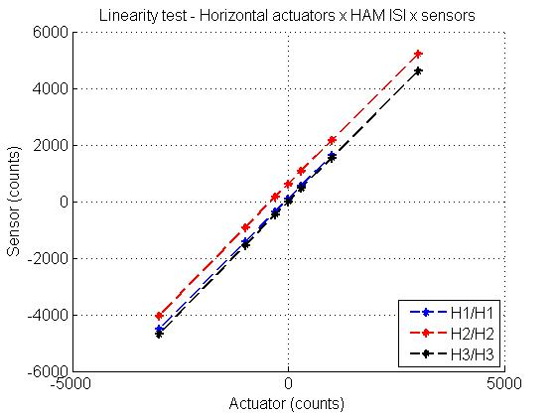
Figure - Horizontal actuators x HAM-ISI x sensors

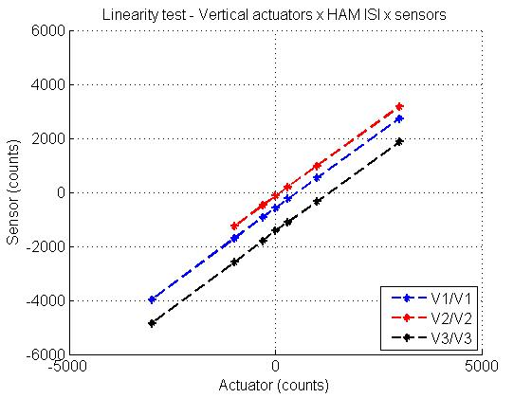
Figure - Vertical actuators x HAM-ISI x sensors

Acceptance criteria:

- Horizontal and vertical slopes of the triplet actuators x HAM-ISI x sensors: Average slope +/- 3%.

Test result: Passed: X Failed: .

Step 16 - Tests in the general coordinate basis
During this step, change of basis matrices are uploaded in MEDM and checked. Locations of the bash script that populates matrices are given in appendix 2. The three matrices are:
- Geo2Cen : from local to Cartesian (Geophones)
- Disp2Cen : from local to Cartesian (Displacement sensors)
- Cont2Act : from cartesian to local (Actuators)

For example, Cont2Act matrix is the following matrix
 | X | Y | Z | rX | rY | rZ
H1 | 0.333 | -0.577 | 0 | 0 | 0 | -0.431
H2 | 0.333 | 0.577 | 0 | 0 | 0 | -0.431
H3 | -0.667 | 0 | 0 | 0 | 0 | -0.431
V1 | 0 | 0 | 0.333 | 0 | -0.937 | 0
V2 | 0 | 0 | 0.333 | 0.812 | 0.469 | 0
V3 | 0 | 0 | 0.333 | -0.812 | 0.469 | 0

with Cartesian_vector = Cont2Act x Local_vector

Procedure to follow for this test:
- Upload change of basis matrices by running scripts presented in appendix 2
- Once populated, test the matrices by performing this test
  - Drive a 1000 counts positive offset in one direction by using the isolation filter bank (MEDM – ISI_HAM_CONT_Direction)
  - Write down CPS values in the table below

 | No drive | X Drive | Y Drive | Z Drive | Rx Drive | Ry Drive | Rz Drive
V1 read out (cts)
V2 read out (cts)
V3 read out (cts)
H1 read out (cts)
H2 read out (cts)
H3 read out (cts)
Direction drive read out (cts)
Table - Tests in the general coordinate basis

Acceptance criteria:

- Direction drive read out must be positive (for a positive drive)
- Reported values must be closed from reference values (to do)

Test result: Passed: Failed: .

